Referential pronouns – from the discourse
Bound pronouns – from the assignment function

Referential and bound look the same because of spellout, they are minimal pronouns and aquire features by agreement chains in the syntax.

Bound versions of 1st and 2nd are rare.

(1) I’m the only one around here who can take care of my children.

“There seems to be no good way to give 1st and 2nd person features interpretations that could produce both indexical and bound variable readings.”

“If a bound variable pronoun entered the derivation with all its features already specified ... If considerations of optimal design play a role in natural language, as suggested in Chomsky (2004, 2005), there should be a bias against checking operations whose main use is to filter out wrongly assembled feature structures. “Crash-proof syntax” 4 should try to minimize the need for filtering. Whenever the shape of a bound variable pronoun is predictable from local properties of its final position, spell-out of such a pronoun should be delayed until it has reached that position” “This argument is essentially the one made against the feature checking approach in the postscript of Halle and Marantz (1993).”

“The current paper departs from Kratzer (1998) in two important respects. The first departure consists in a separation of logophoric and non-logophoric fake indexicals.”

“It must be possible for them to have certain features even at the earliest stage of their derivation.” Rullmann (2004).

(4) You must each fill out a questionnaire before our first conversation.

‘each of you is an x such that x will fill out a questionnaire before the first conversation of x and me’.

Our must have had a 1st person feature from the start.

we need a principled account of which features such a pronoun can be born with, and which ones it has to acquire via feature transmission

The most surprising conclusion of the paper is that the relationship between a bound variable pronoun and its antecedent obeys locality constraints like any other known anaphoric relationship.

German requires an unbroken agreement chain
English doesn’t require an unbroken agreement chain.
Claim: the differences between English and German are due to different reaction to a phonological spell-out dilemma.

The 1st person plural is possible in German, there is a 1st/3rd plural syncretism in verbs. The syncretism allows the chain of wir, sind, die, unsere versogen.

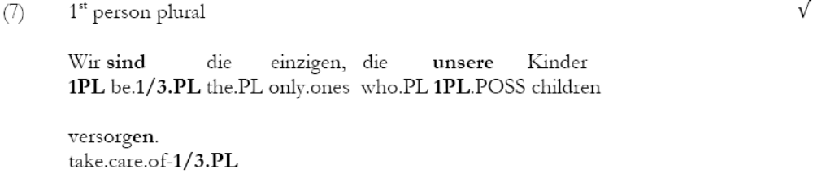there are 5 agreement chains:
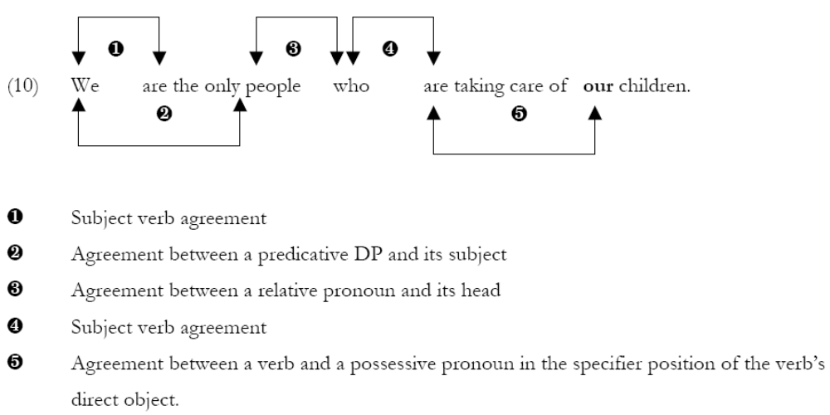
To get the two questionable links we have to assume that what looks like a 3rd person pronoun (who,die) DP can aquire 1st and 2nd person features from its subject (null we) and transmit them to a 3rd person relative pronoun.
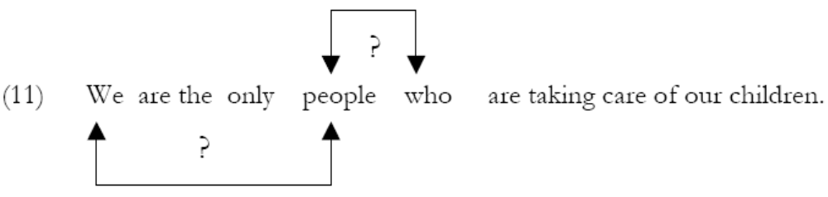

Some have suggested that 3rd person feature are the absence of features, alternatively kratzer adopts the proposal that 3rd person is gender features. She uses

“According to the Subset Principle of Halle (1997) and Embick & Noyer (forthcoming), a vocabulary item can be inserted into a position if the item matches at least a subset of the features present in that position and there is no other vocabulary item that is a better match7.”

“Competition for insertion only affects functional heads, that is, the abstract morphemes of Embick & Noyer (forthcoming), and not roots like vCOW, for example. Assuming, as we do, that phonological spell-out cannot affect the semantic interpretation component, roots must be sufficiently specified from the very start. This is consistent with Embick & Noyer (forthcoming), who argue that roots have all of their features throughout the derivation.”

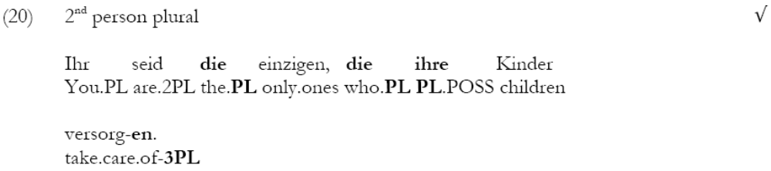

“I have relied on German, a language with relatively rich verbal inflections, to argue that the availability of bound variable readings for 1st and 2nd person pronouns requires unbroken agreement chains leading to a suitable antecedent.”

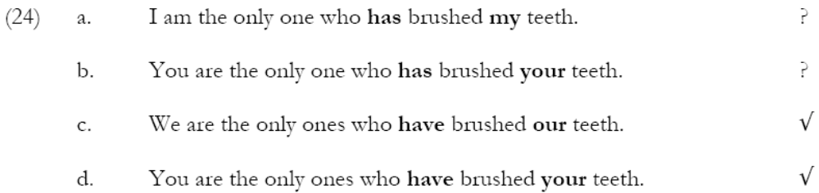

From the current perspective, the availability of a bound variable reading in 24(a) and (b) is surprising.

It could also mean that a 1st or 2nd person feature was in fact transmitted, but the resulting spell-out dilemma was resolved - in this case in favor of gender agreement.

I am the one who hates myself
1sg be.1sg X hate-3sg reflexive-1sg

